INCIDENT LIFECYCLE AUTOMATION IN SERVICENOW
1. INTRODUCTION
1.1 Project Overview
Incident management is an essential component of IT Service Management (ITSM), responsible for restoring normal IT services as quickly as possible after an interruption or failure. In traditional incident management systems, many activities such as incident creation, assignment, prioritization, communication, resolution, and closure may require significant manual effort.
The Incident Lifecycle Automation in ServiceNow project was developed to automate and streamline the complete incident management lifecycle using the ServiceNow platform. The solution uses workflow automation to manage incidents from their initial creation through assignment, investigation, resolution, and closure.
The project also integrates Knowledge Management to help support teams find existing solutions for recurring issues and Change Management to handle incidents that require modifications to IT infrastructure or services.
The primary objective is to reduce manual intervention, improve incident resolution time, standardize the incident handling process, and increase overall IT service efficiency.
The project was implemented and completed through the Skill Wallet learning and project milestones, covering the major activities required to build and demonstrate an automated Incident Management solution in ServiceNow.
1.2 Purpose
The purpose of this project is to develop an automated Incident Management solution that:
- Automates the incident lifecycle.
- Reduces manual effort in incident handling.
- Automatically manages incident assignment and workflow progression.
- Helps support teams identify solutions using Knowledge Management.
- Integrates Change Management when a change is required for resolution.
- Improves incident resolution efficiency.
- Provides a standardized approach to incident management.
- Reduces recurring incidents through the reuse of documented knowledge.
- Improves visibility and tracking of incidents.
- Demonstrates practical implementation of ITSM concepts using ServiceNow.

2. IDEATION PHASE
2.1 Problem Statement
Organizations frequently face IT-related issues such as application failures, network problems, system unavailability, access issues, and hardware or software problems. When these incidents are handled manually, the process can become slow and inconsistent.
Common problems include:
- Manual incident creation and assignment.
- Delays in assigning incidents to appropriate support teams.
- Difficulty identifying previously solved problems.
- Repeated incidents due to lack of knowledge reuse.
- Lack of standardized incident workflows.
- Delayed communication between users and support teams.
- Difficulty tracking incident status.
- Manual coordination when infrastructure changes are required.
- Increased resolution time.
- Limited visibility into the complete incident lifecycle.
Therefore, there is a need for an automated system that can manage incidents systematically from creation to closure.
Problem Statement
To develop an automated Incident Management solution in ServiceNow that streamlines the complete incident lifecycle, automates workflow activities, integrates Knowledge Management and Change Management, and enables faster and more efficient incident resolution.

2.2 Empathy Map Canvas
An empathy map was created to understand the requirements and difficulties faced by users and IT support teams.
User Says
- "My issue needs to be resolved quickly."
- "I don't know the status of my incident."
- "I faced the same issue previously."
- "I want an easy way to report problems."
- "I need timely updates about my incident."
User Thinks
- "Why is my issue taking so long to resolve?"
- "Has my incident been assigned to the right team?"
- "Can the support team use an existing solution?"
- "Will I have to report the same issue again?"
User Does
- Reports IT problems.
- Checks incident status.
- Communicates with support teams.
- Provides additional information when requested.
- Confirms whether the issue has been resolved.
User Feels
- Frustrated when an issue is unresolved.
- Confused when incident status is unclear.
- Satisfied when issues are resolved quickly.
- Confident when the system provides regular updates.
Pain Points
- Long resolution times.
- Manual incident processing.
- Repeated troubleshooting.
- Lack of communication.
- Difficulty finding previous solutions.
Needs
- Simple incident creation.
- Automatic assignment.
- Faster resolution.
- Access to previous solutions.
- Transparent incident tracking.
- Effective communication.

2.3 Brainstorming
During the brainstorming stage, different ideas were considered to improve the incident management process.
Ideas Identified
- Automated incident creation.
- Automatic incident categorization.
- Priority-based incident handling.
- Automatic assignment to support groups.
- Workflow-based incident progression.
- Integration with Knowledge Management.
- Integration with Change Management.
- Automated notifications.
- Incident status tracking.
- Reuse of previously documented solutions.
- Automated incident closure.
- Reporting and monitoring of incidents.
Selected Idea
The selected solution was Incident Lifecycle Automation in ServiceNow, because ServiceNow provides a centralized ITSM platform capable of managing incidents, knowledge articles, workflows, and changes within a unified environment.

3. REQUIREMENT ANALYSIS PHASE
3.1 Customer Journey Map
The customer journey describes how a user interacts with the incident management system.
Stage | User Activity | System Activity | User Experience
Incident Identification | User experiences an IT issue | User initiates incident creation | Needs quick support
Incident Creation | Provides issue details | Incident record is created | Easy reporting
Assignment | Waits for support | Incident assigned to appropriate group | Improved transparency
Investigation | Provides additional information | Support team investigates | Faster communication
Knowledge Search | Waits for solution | Existing knowledge articles are checked | Faster troubleshooting
Change Requirement | Change may be required | Change process is initiated | Controlled modification
Resolution | Confirms issue resolution | Incident is updated with resolution details | Satisfied
Closure | Reviews final status | Incident is closed | Completed

3.2 Solution Requirements
Functional Requirements
The system should:
- Allow users to create incidents.
- Capture incident information such as description, category, priority, and impact.
- Automatically process incidents using workflows.
- Assign incidents to appropriate support groups.
- Allow support agents to update incident status.
- Provide access to relevant knowledge articles.
- Support escalation when required.
- Integrate with Change Management.
- Record resolution information.
- Allow incidents to be closed after resolution.
- Maintain incident history.
- Provide visibility into the incident lifecycle.
Non-Functional Requirements
The system should provide:
- Reliability.
- Security.
- Usability.
- Scalability.
- Maintainability.
- Fast response time.
- Data consistency.
- Controlled access based on user roles.

3.3 Data Flow Diagram
The major data flow of the proposed system is:
User → Incident Creation → Incident Record → Classification & Prioritization → Assignment → Investigation → Knowledge Management → Change Management (if required) → Resolution → User Confirmation → Incident Closure
Main Components
User
Provides incident information and receives updates.
Incident Management
Stores and manages incident records throughout their lifecycle.
Workflow Automation
Controls the movement of incidents between different stages.
Knowledge Management
Provides previously documented solutions to support agents.
Change Management
Handles changes required to resolve incidents.
Support Team
Investigates incidents and implements appropriate solutions.
Resolution & Closure
Records the final resolution and closes the incident.

3.4 Technology Stack
Technology | Purpose
ServiceNow | ITSM platform
Incident Management | Incident lifecycle management
Workflow Automation | Automating incident processes
Knowledge Management | Reusing existing solutions
Change Management | Managing required IT changes
ServiceNow Tables | Storing incident and related records
ServiceNow Forms | Data entry and record management
ServiceNow Notifications | Communication and updates
ServiceNow User/Group Management | Assignment and access control

4. PROJECT DESIGN PHASE
4.1 Problem-Solution Fit
The proposed solution directly addresses the problems identified during the ideation phase.
Problem | Proposed Solution
Manual incident processing | Workflow automation
Delayed assignment | Automated assignment
Repeated troubleshooting | Knowledge Management
Poor incident visibility | Centralized incident records
Slow resolution | Standardized workflows
Change coordination problems | Change Management integration
Lack of communication | Automated notifications
Inconsistent processes | Standardized incident lifecycle
The solution therefore provides a strong fit between the identified organizational problems and the capabilities provided by ServiceNow.

4.2 Proposed Solution
The proposed system automates the incident lifecycle using ServiceNow.
The workflow begins when an incident is created. The incident is then classified and prioritized based on the information provided. The appropriate support group receives the incident for investigation.
The support team can search the Knowledge Base for existing solutions. If an appropriate knowledge article is available, the solution can be applied to resolve the incident.
If the incident requires an infrastructure or configuration modification, the Change Management process can be initiated. After the required change is implemented and the issue is resolved, the incident is updated with resolution details.
Finally, the incident proceeds toward closure after the resolution is confirmed.
Automated Lifecycle
New → Assigned → In Progress → Resolved → Closed
Additional workflow activities such as escalation, knowledge lookup, notifications, and change requests can occur depending on incident requirements.

4.3 Solution Architecture
The architecture consists of the following major layers:
User Layer
Users interact with ServiceNow to create incidents and track their status.
ServiceNow Application Layer
ServiceNow provides the central environment for Incident Management, Knowledge Management, and Change Management.
Automation Layer
Workflows and automation rules control incident assignment, status progression, notifications, and other activities.
Knowledge Layer
Knowledge articles provide previously documented solutions to help support agents resolve incidents efficiently.
Change Management Layer
When an incident requires a system or infrastructure change, the corresponding change process is initiated.
Data Layer
ServiceNow tables maintain incident records, user information, assignment details, knowledge information, change records, and resolution data.

5. PROJECT PLANNING & SCHEDULING PHASE
5.1 Project Planning
The project was planned and executed through a sequence of milestones in Skill Wallet. Each milestone represented an important stage of the project implementation.
Project Milestones
Milestone 1 – Understanding the Problem
- Understand the Incident Management process.
- Identify limitations of manual incident handling.
- Define the project problem statement.
- Identify the need for workflow automation.
Milestone 2 – Understanding ServiceNow
- Understand the ServiceNow platform.
- Explore the Incident Management module.
- Understand users, groups, roles, and incident records.
- Study the ServiceNow interface and navigation.
Milestone 3 – Incident Management Setup
- Configure and work with incident records.
- Understand incident fields.
- Create and manage incidents.
- Understand incident states and priorities.
- Configure incident assignment.
Milestone 4 – Incident Lifecycle Automation
- Design the incident workflow.
- Automate incident progression.
- Configure assignment and status transitions.
- Implement workflow-based incident management.
- Reduce manual intervention.
Milestone 5 – Knowledge Management Integration
- Understand Knowledge Management.
- Create/use knowledge articles.
- Connect existing solutions with incident resolution.
- Improve troubleshooting efficiency.
- Reduce repeated problem-solving efforts.
Milestone 6 – Change Management Integration
- Understand Change Management.
- Identify incidents requiring changes.
- Integrate incident resolution with change processes.
- Ensure controlled implementation of required changes.
Milestone 7 – Testing and Validation
- Create sample incidents.
- Execute different incident scenarios.
- Verify workflow transitions.
- Validate assignment and resolution processes.
- Test Knowledge Management integration.
- Test Change Management integration.
Milestone 8 – Final Project Completion
- Complete all Skill Wallet milestones.
- Validate the complete incident lifecycle.
- Verify the automated workflow.
- Capture project outputs.
- Prepare project documentation and demonstration.
Project Schedule
Phase | Major Activities
Phase 1 | Ideation and problem identification
Phase 2 | Requirement analysis
Phase 3 | Solution and architecture design
Phase 4 | Planning and milestone execution
Phase 5 | ServiceNow implementation and testing
Final Stage | Results, documentation, and demonstration

6. PROJECT DEVELOPMENT PHASE
6.1 Development and Implementation
The project was implemented using the ServiceNow platform. The development process focused on creating an automated incident lifecycle and integrating supporting ITSM capabilities.
Step 1 – Incident Creation
An incident record is created with relevant information such as:
- Caller
- Short description
- Description
- Category
- Subcategory
- Impact
- Urgency
- Priority
- Assignment group
- Assigned user
- Status
Step 2 – Classification and Prioritization
The incident is analyzed based on its impact and urgency. Appropriate classification and priority are established to determine the level of attention required.
Step 3 – Automated Assignment
The incident is routed to the appropriate support group so that the responsible team can begin investigation.
Step 4 – Investigation
The support team investigates the incident and records relevant activities and updates in the incident record.
Step 5 – Knowledge Management
The support team can search the Knowledge Base for existing solutions related to the reported issue.
If a suitable article is found, the documented solution can be used to resolve the incident more efficiently.
Step 6 – Change Management
If the incident cannot be resolved without modifying an IT service, configuration, or infrastructure component, a change request can be initiated.
The change is managed through the Change Management process before the incident is finally resolved.
Step 7 – Resolution
After the underlying issue has been addressed, the support team records:
- Resolution notes.
- Resolution code.
- Actions performed.
- Relevant knowledge used.
- Change information, if applicable.
Step 8 – Closure
After successful resolution and confirmation according to the configured process, the incident is moved toward closure.

7. FUNCTIONAL AND PERFORMANCE TESTING
7.1 Functional Testing
The implemented system was tested using different incident scenarios.
Test Case | Expected Result | Status
Create new incident | Incident record should be created | Passed
Update incident details | Information should be updated successfully | Passed
Assign incident | Incident should reach appropriate support group | Passed
Change incident status | Status should transition correctly | Passed
Search knowledge article | Relevant knowledge should be accessible | Passed
Resolve incident | Resolution information should be recorded | Passed
Close incident | Incident should move to closure | Passed
Initiate change | Change process should be available when required | Passed
Track incident | User/agent should be able to view status | Passed
7.2 Performance Testing
Performance testing focused on verifying that the automated workflow operates efficiently.
The following areas were evaluated:
- Incident creation response.
- Form and record loading.
- Workflow execution.
- Incident assignment.
- Status updates.
- Knowledge article access.
- Change request initiation.
- Incident resolution and closure.
The system performed the required operations successfully within the ServiceNow environment during project validation.

8. RESULTS
8.1 Project Results
The project successfully implemented an automated Incident Management solution in ServiceNow.
The completed system provides:
- Automated incident lifecycle management.
- Structured incident processing.
- Improved incident assignment.
- Workflow-based status progression.
- Knowledge-based troubleshooting.
- Change Management integration.
- Centralized incident tracking.
- Improved resolution efficiency.
- Reduced manual intervention.
- Better visibility of incident status.
The project milestones provided through Skill Wallet were completed successfully, and the final implementation demonstrated the complete incident lifecycle.

8.2 Output Screenshots
The following screenshots can be added to demonstrate the implementation:
Phase2: Create New Service And Service Offering
1.Create New Service
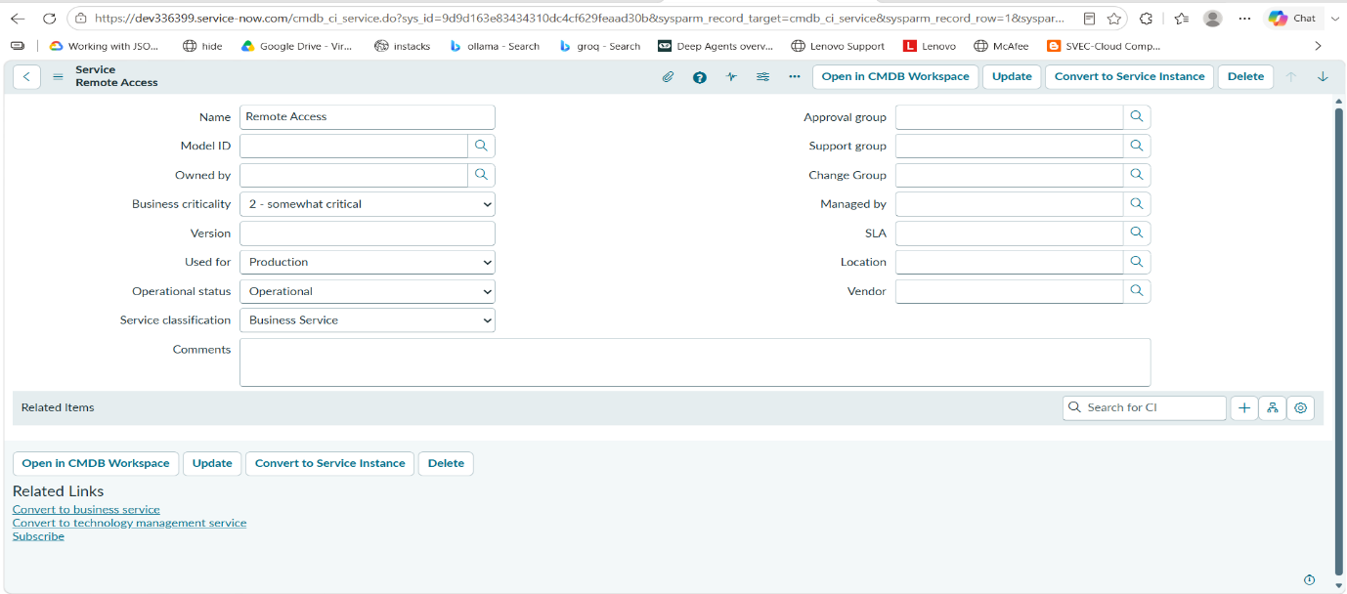

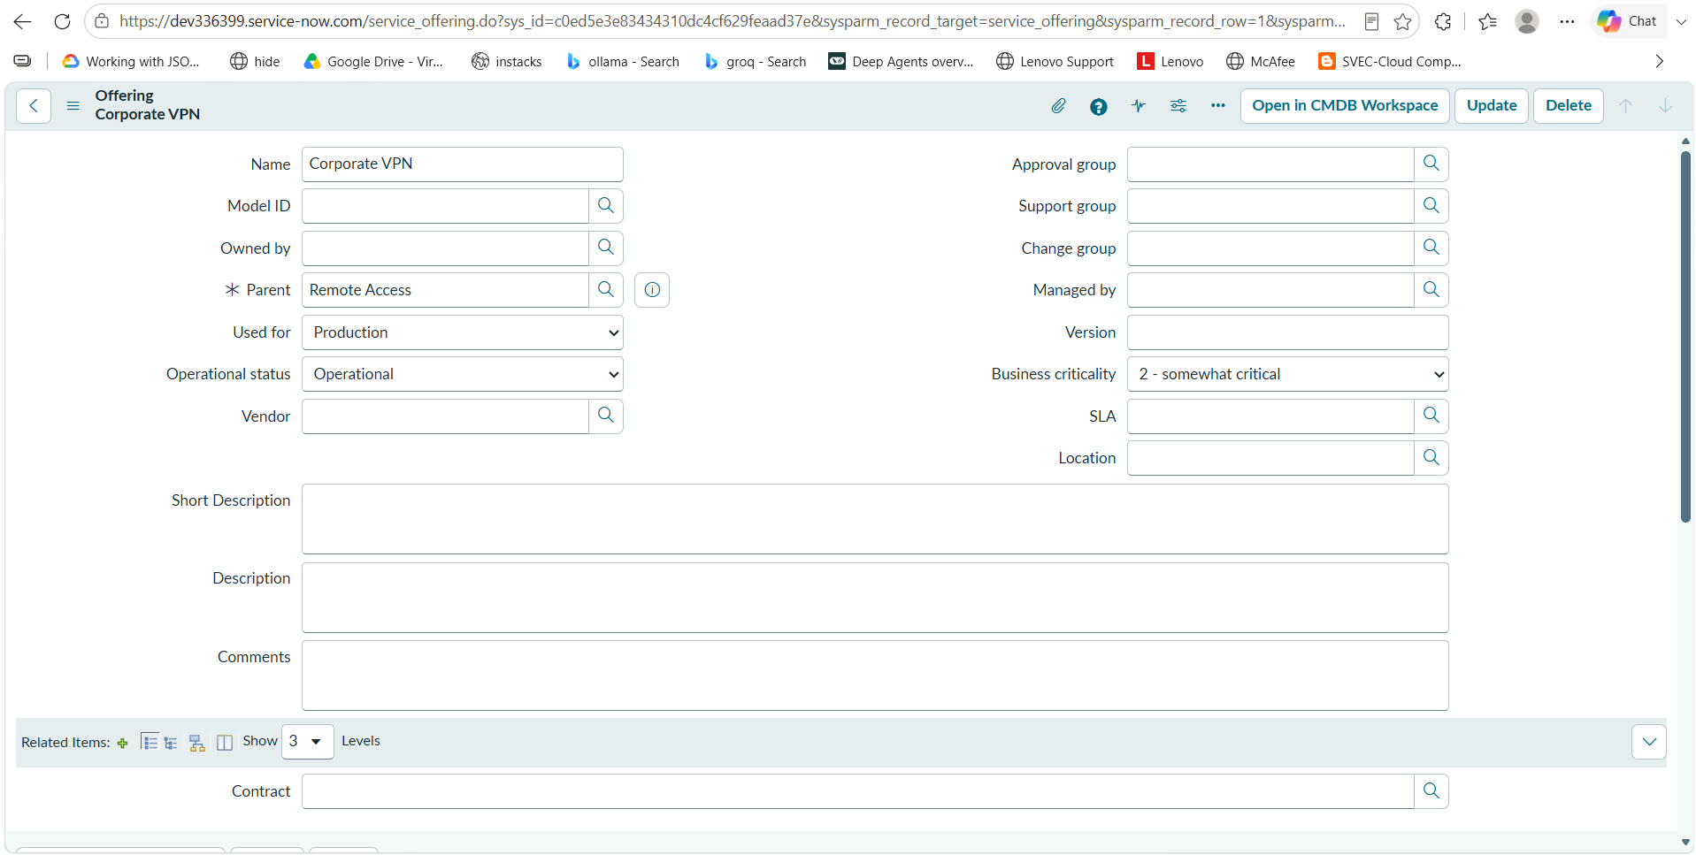
2.Create New Service Offering

Phase3:Incident Record Creation
1.Incident Creation
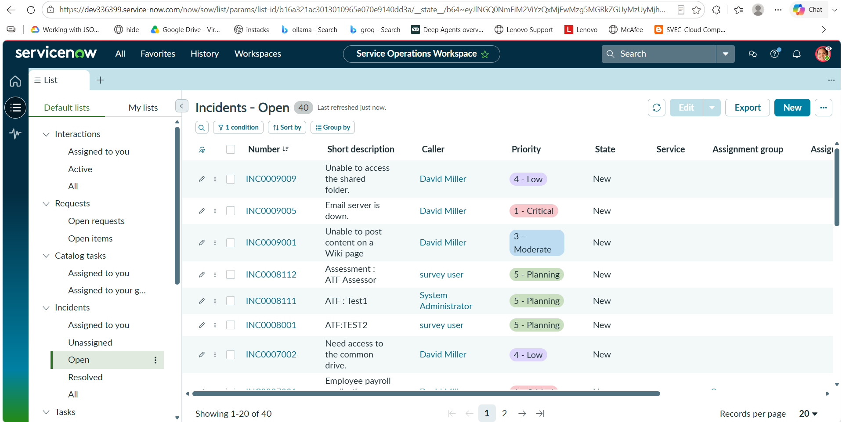

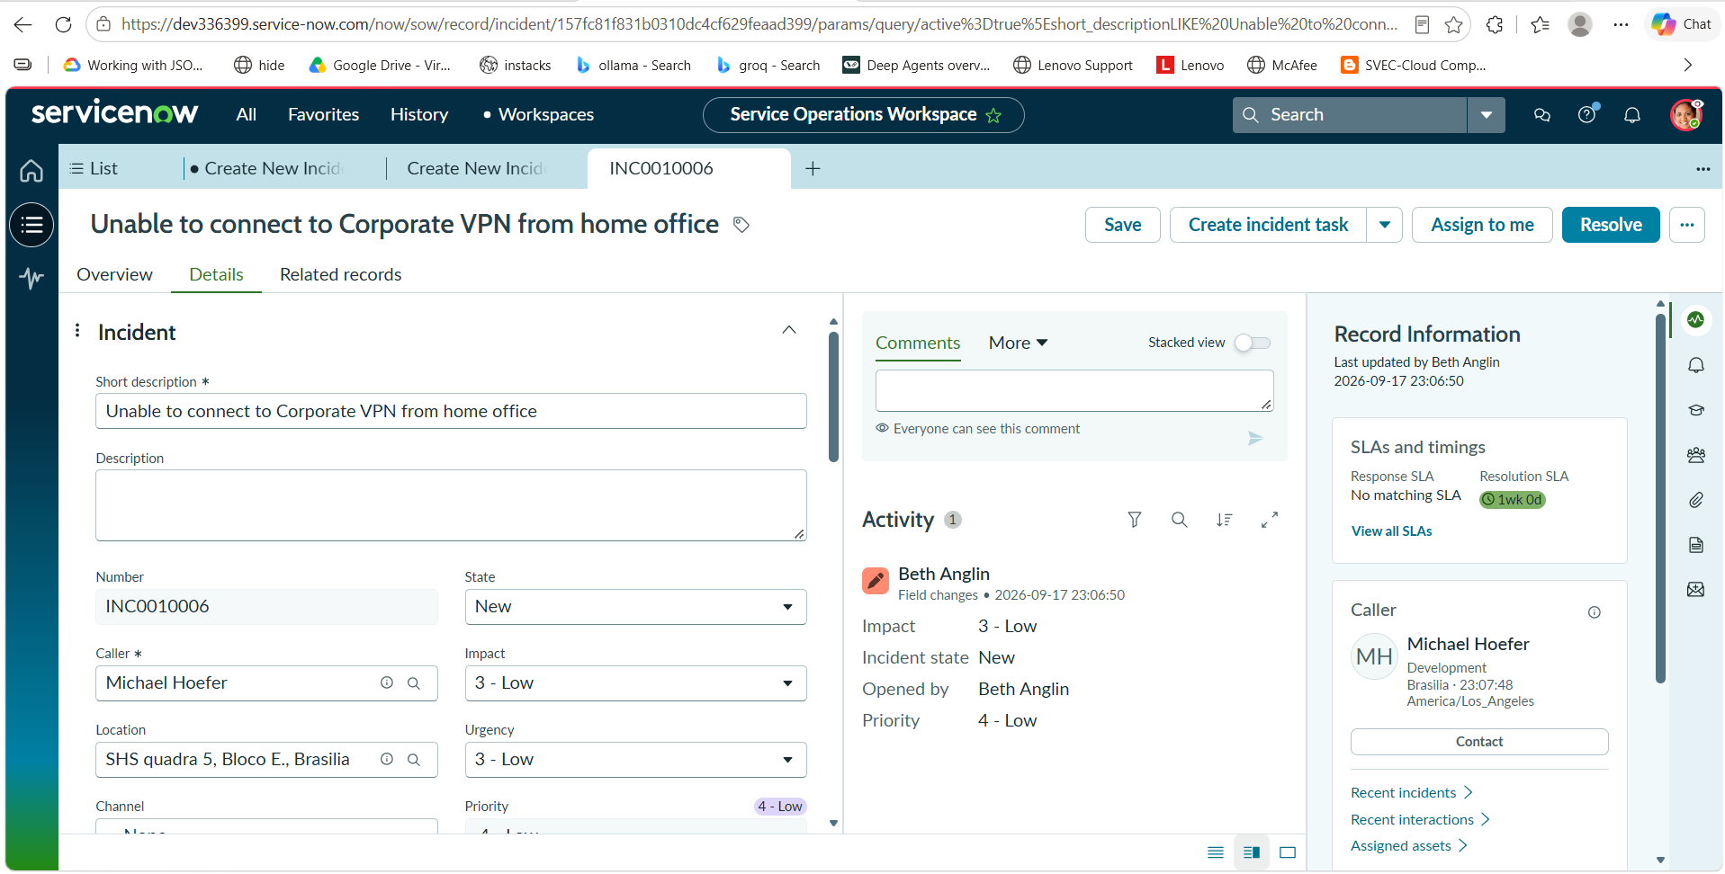

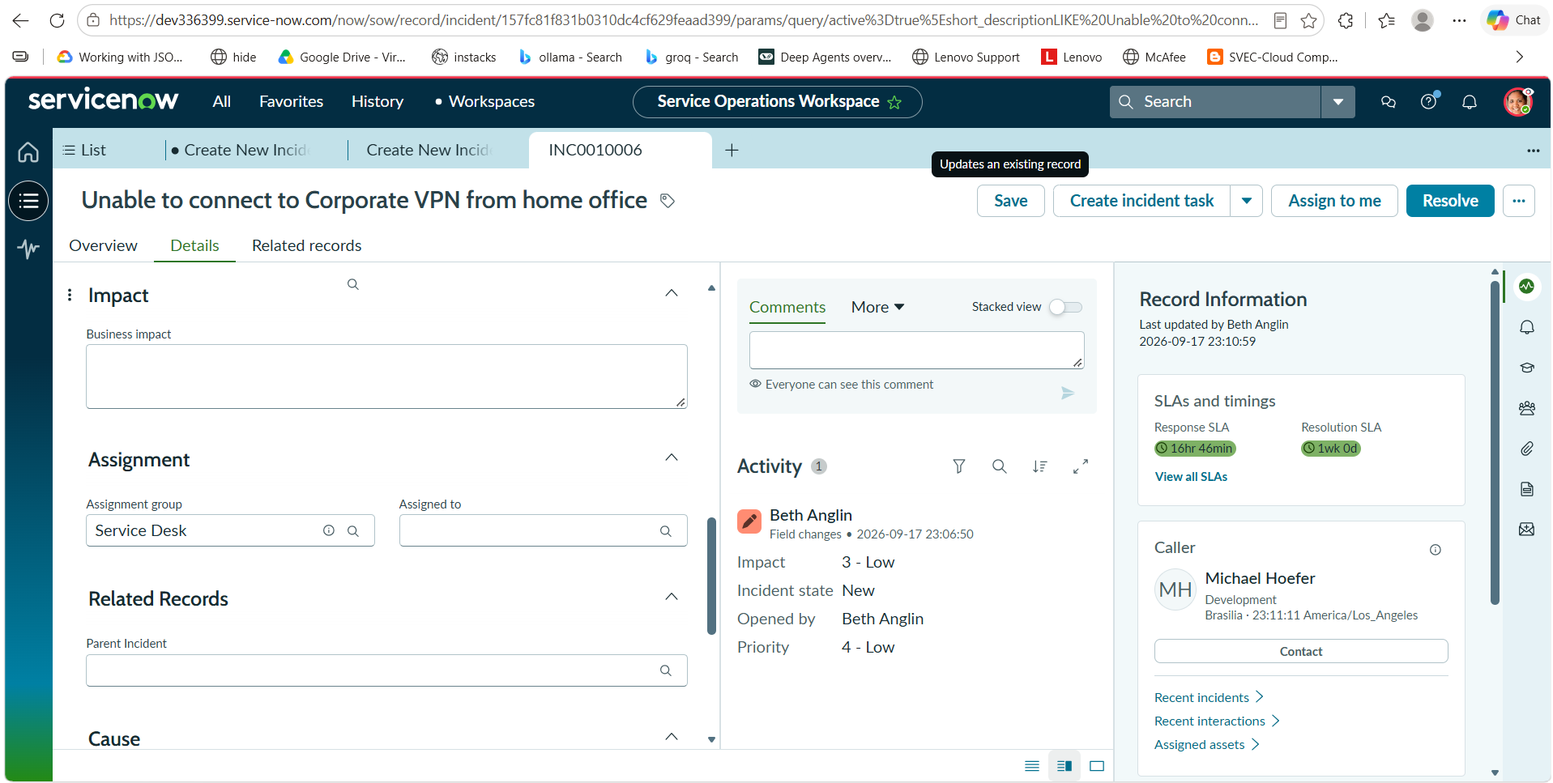

Phase4:Incident Classification

1.Updating Incident Details

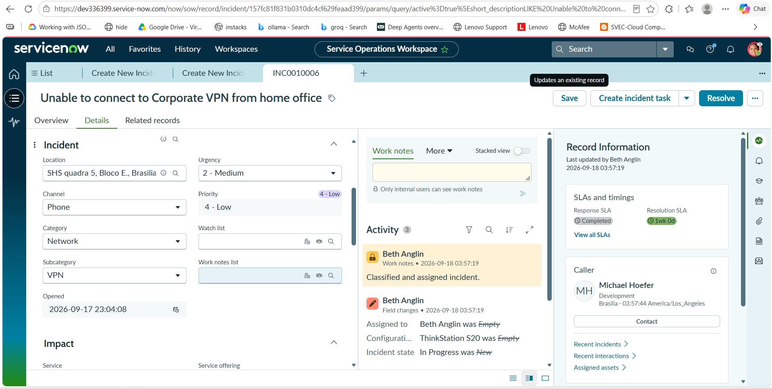

Phase5:Knowledge Integration
1.Agent Assist Verification

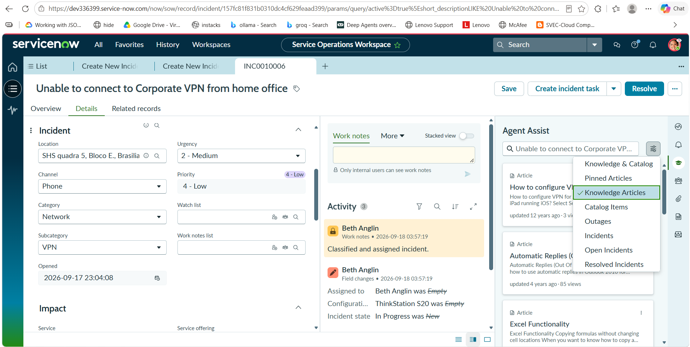

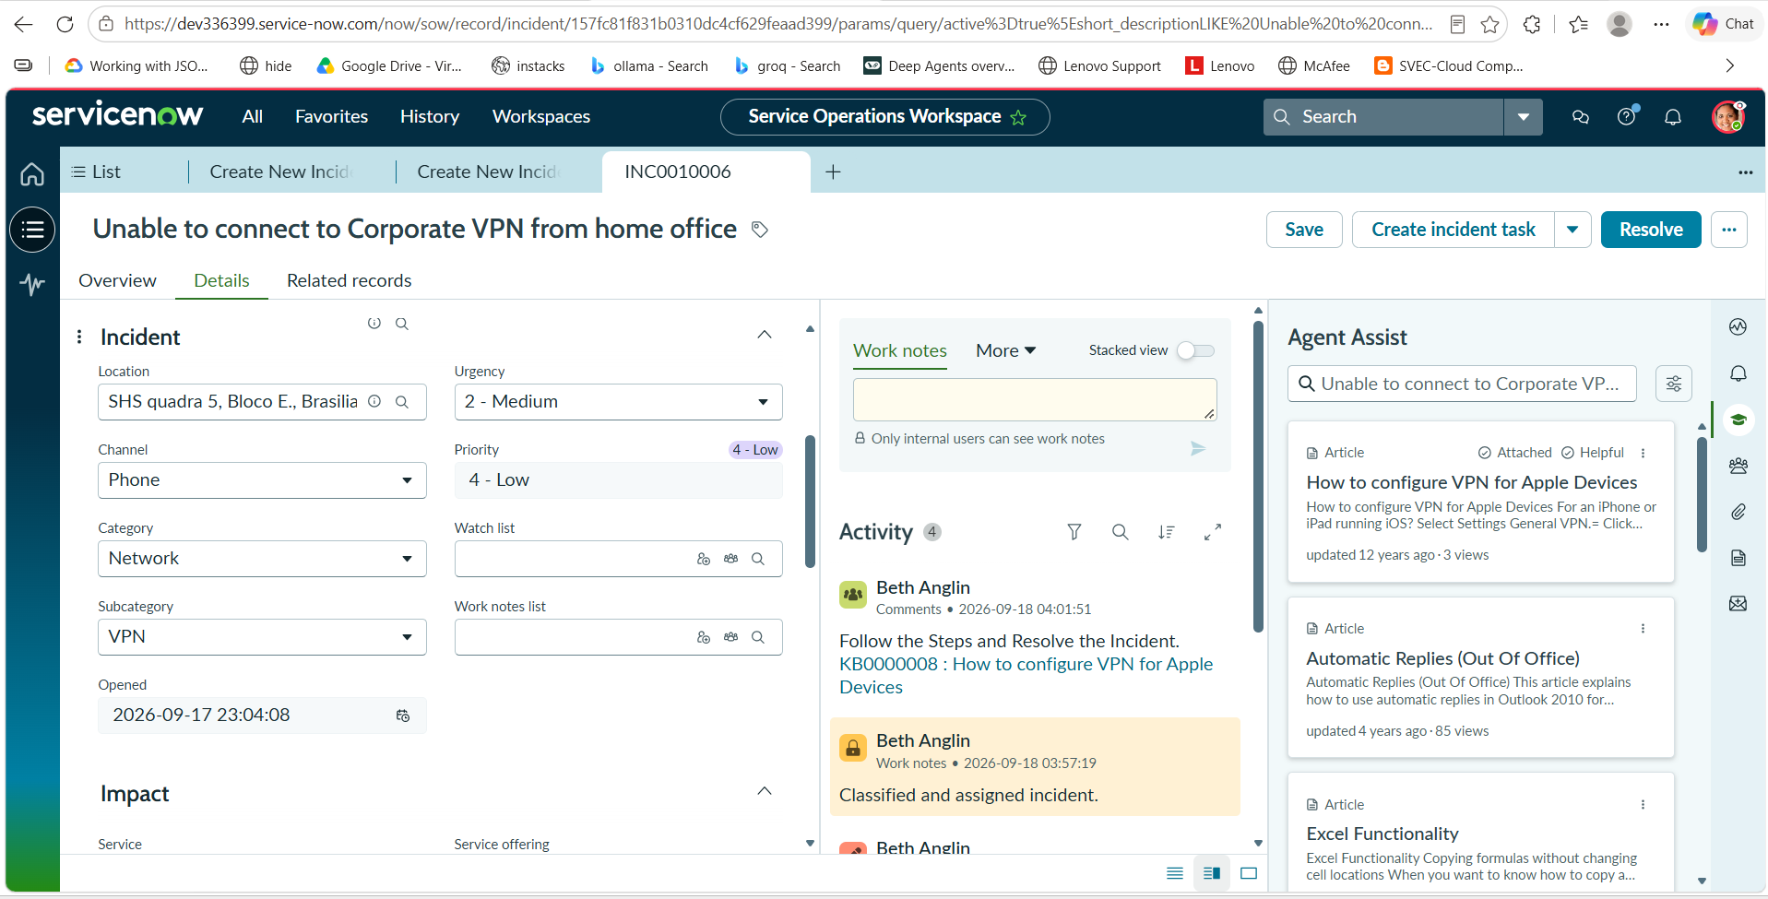

Phase6:Reassignment And Escalation
1.Watch List Update

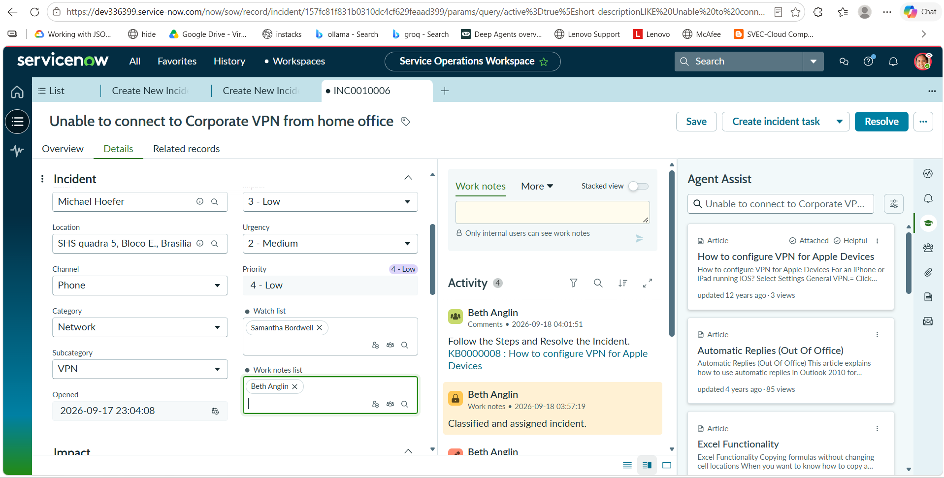

2.Reassignment

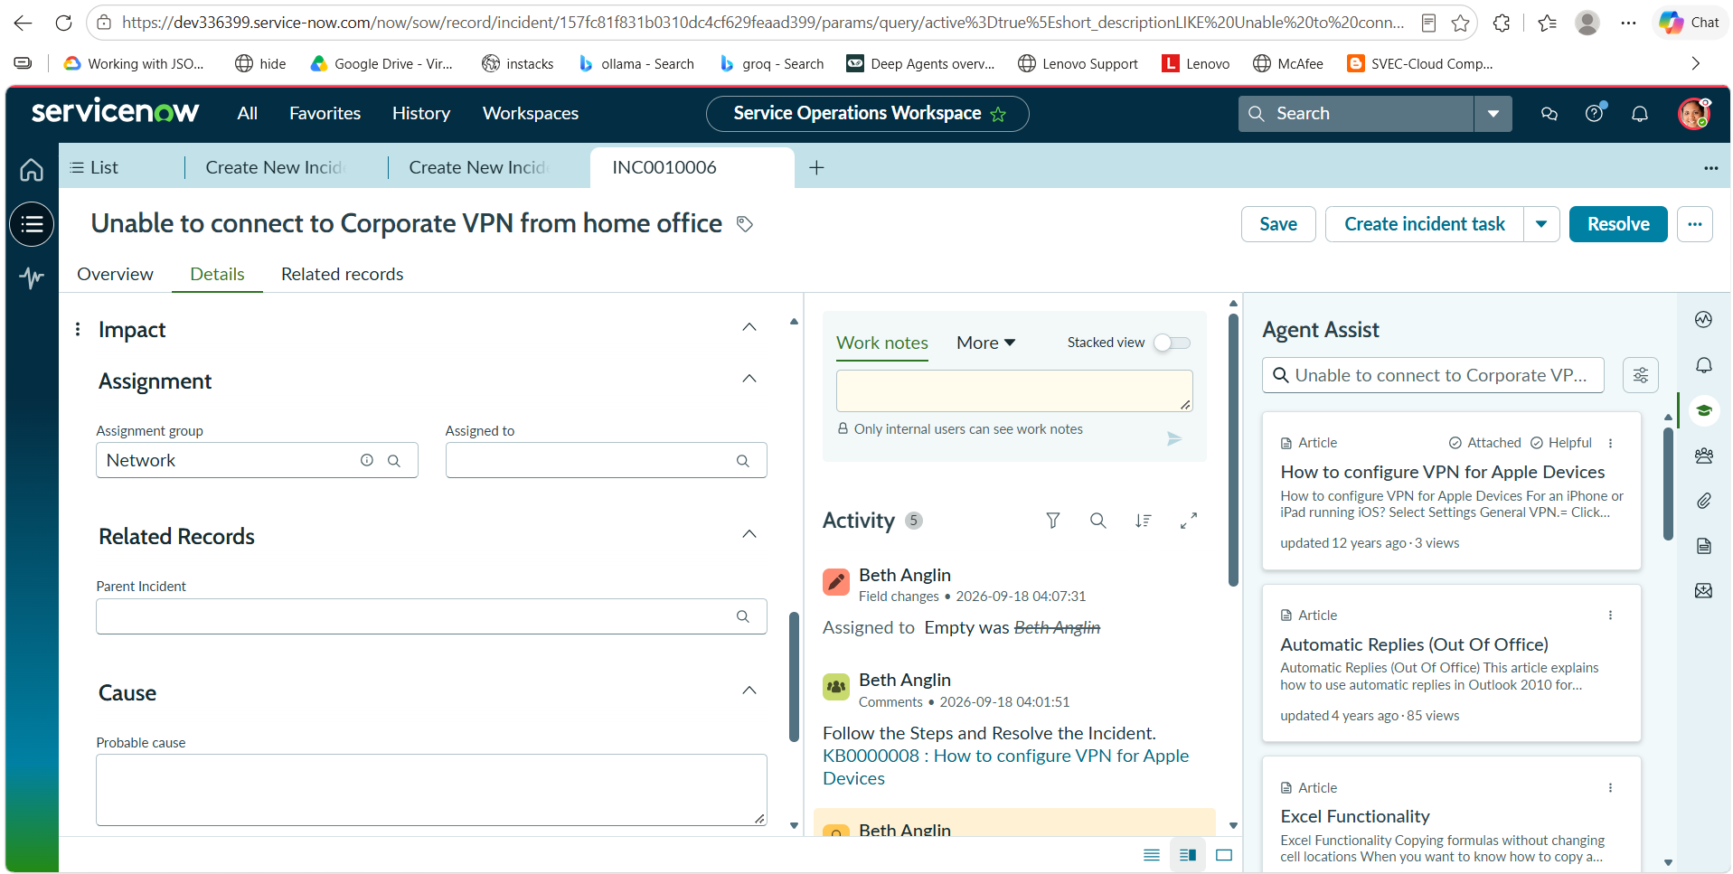

Phase7:Incident Tracking by Level 2
1.Investigation by Network Team
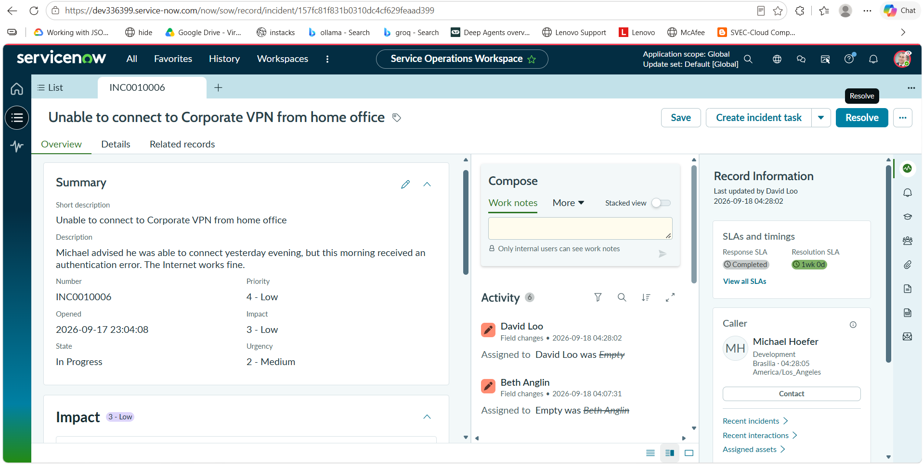
Phase8:Emergency Change Request Creation

1.Create Change
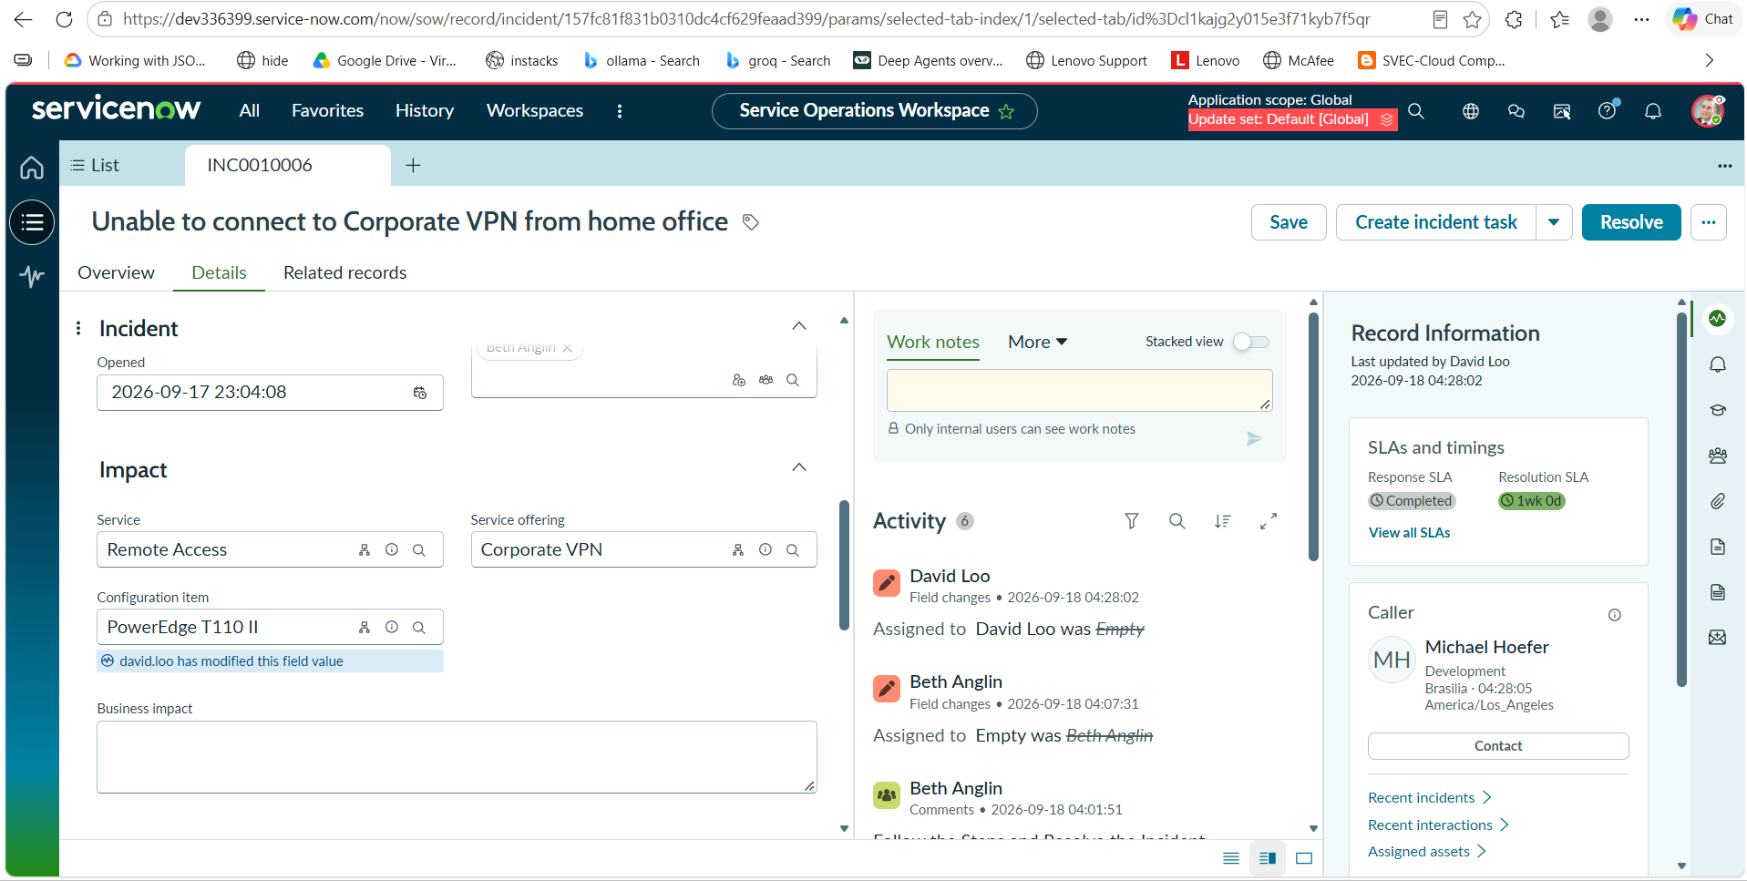
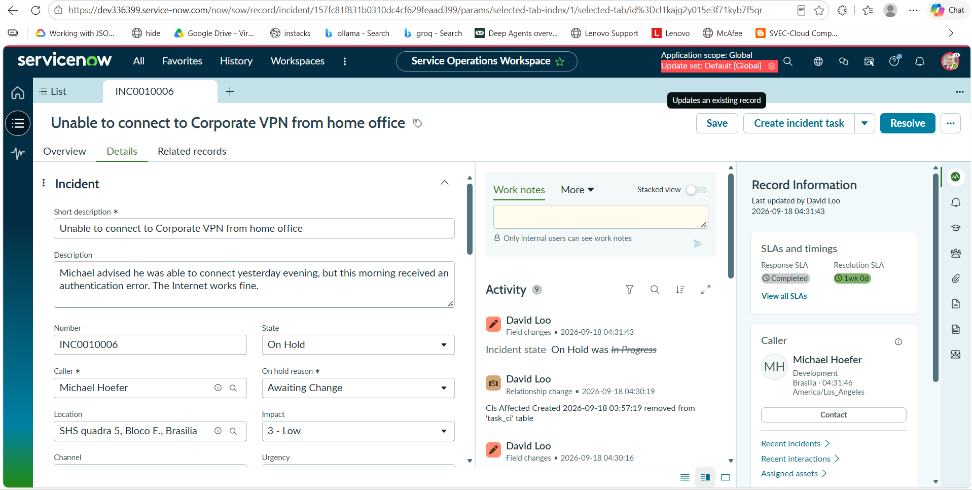

Phase9:Child Incident Creation

1.Create Child Incident
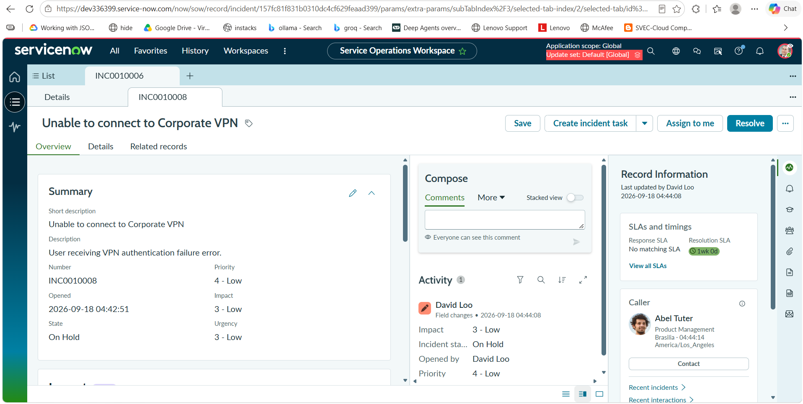

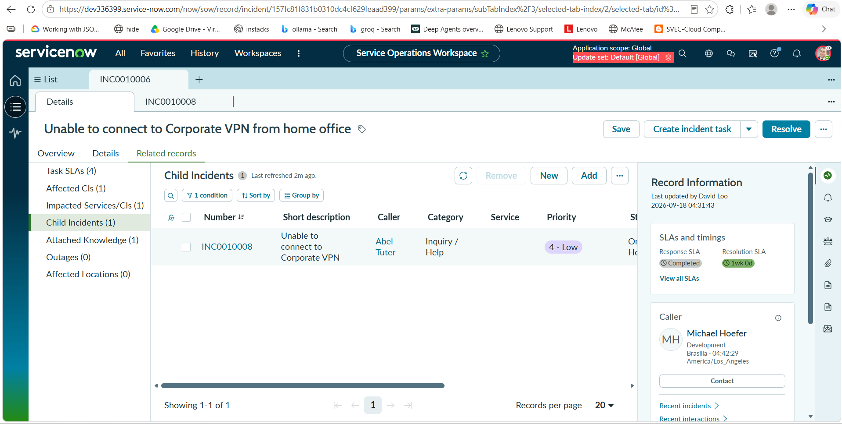

Phase10:Incident Resolution

1.Add Cause
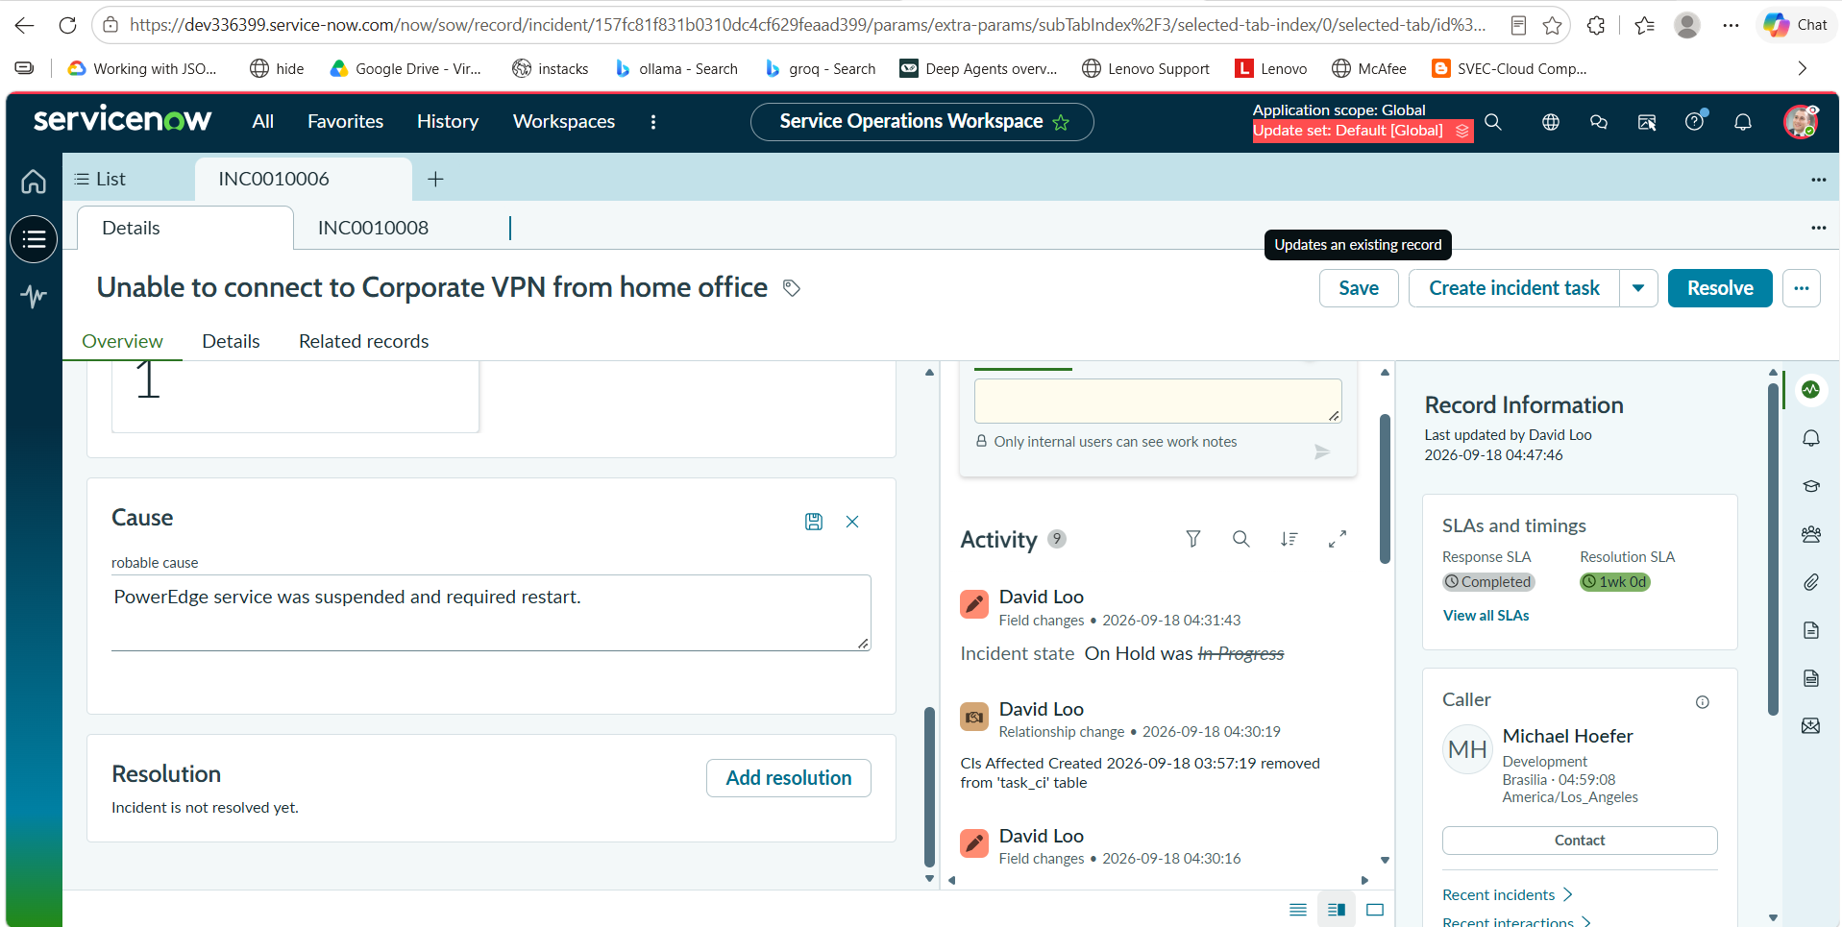

2.Add resolution
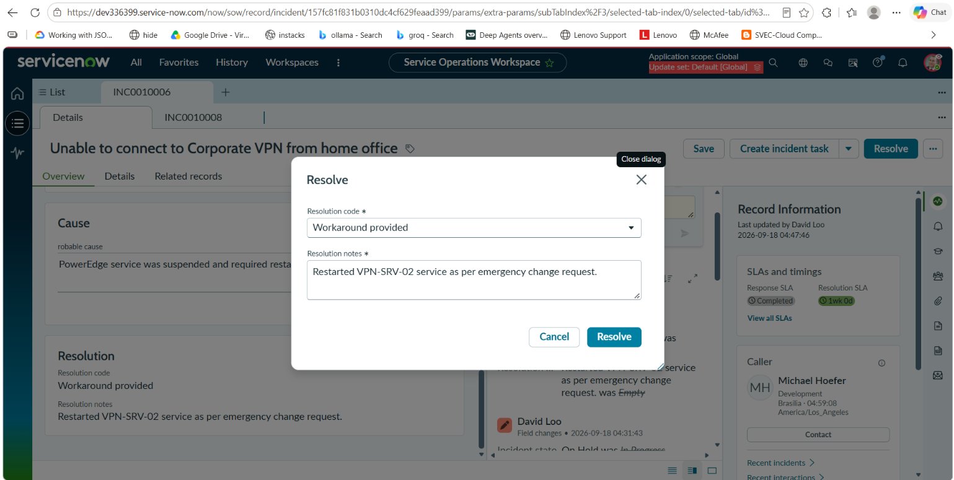

Phase11:Create Knowledge Article
1.Create knowledge Article

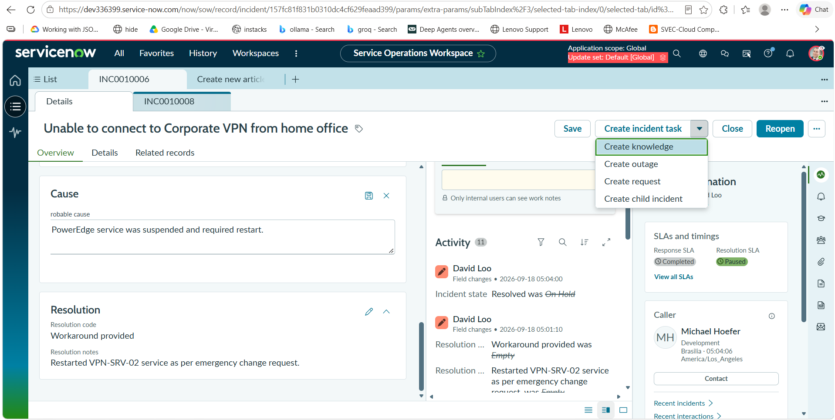

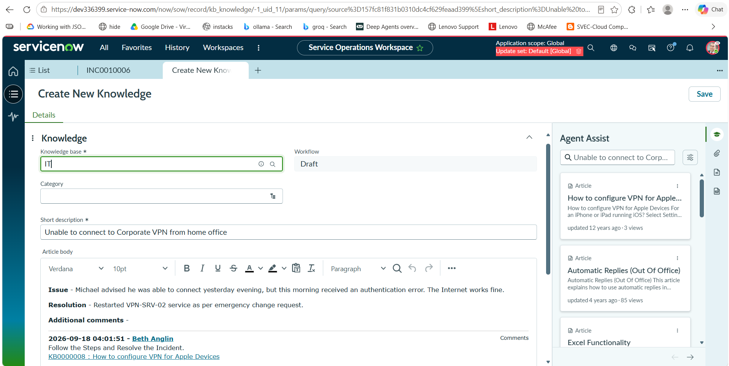

Phase12:Final Validation
1.Final Validation
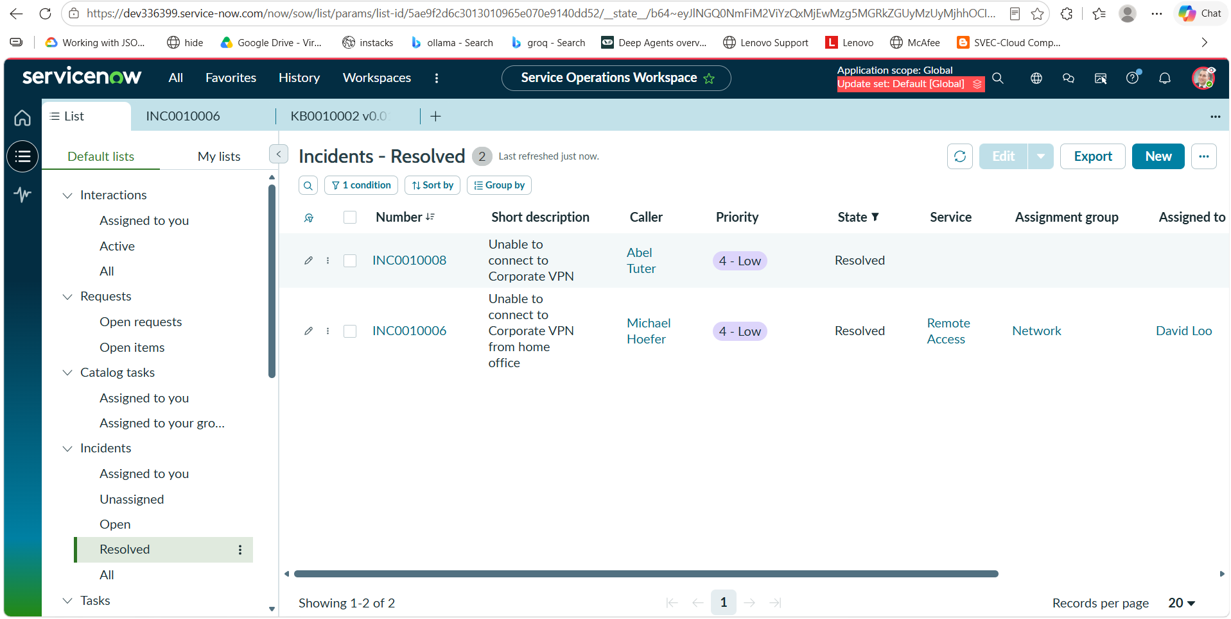

9. ADVANTAGES AND DISADVANTAGES
9.1 Advantages
- Automation
Reduces manual intervention in incident processing.
- Faster Resolution
Workflow automation and knowledge reuse help reduce resolution time.
- Centralized Management
All incident information is maintained in a centralized platform.
- Improved Visibility
Users and support teams can track incident progress.
- Knowledge Reuse
Existing solutions can be reused for recurring incidents.
- Controlled Changes
Change Management provides a structured approach to required modifications.
- Standardized Process
The incident lifecycle follows a consistent process.
- Improved IT Service Efficiency
Automation enables support teams to focus more on troubleshooting and resolution.
9.2 Disadvantages
- Initial configuration can require considerable effort.
- Users and administrators require ServiceNow knowledge.
- Complex workflows may require additional configuration.
- ServiceNow licensing and platform costs may be significant for organizations.
- Poorly configured workflows can affect the incident management process.
- Continuous maintenance may be required as organizational requirements change.

10. CONCLUSION
The Incident Lifecycle Automation in ServiceNow project successfully demonstrates how ServiceNow can be used to automate and manage the complete incident lifecycle.
The solution begins with incident creation and continues through classification, prioritization, assignment, investigation, knowledge-based troubleshooting, change management, resolution, and closure.
By integrating Incident Management, Knowledge Management, and Change Management, the solution provides a structured and efficient approach to IT service management.
The implementation completed through the Skill Wallet milestones provided practical experience in configuring and managing ServiceNow ITSM processes. The project demonstrates that workflow automation can reduce manual effort, improve incident visibility, accelerate issue resolution, and improve overall IT service efficiency.
Thus, the developed solution provides a practical foundation for organizations seeking to modernize and automate their incident management processes.

11. FUTURE SCOPE
The project can be further enhanced with the following features:
11.1 AI-Based Incident Classification
Artificial Intelligence can be used to automatically classify incidents based on their descriptions and historical data.
11.2 Predictive Incident Management
Machine Learning can be introduced to predict incident priority, resolution time, and possible recurring incidents.
11.3 Automated Knowledge Recommendations
The system can automatically recommend relevant knowledge articles based on the incident description.
11.4 Virtual Agent Integration
A ServiceNow Virtual Agent can be integrated to allow users to report incidents and receive troubleshooting assistance through conversational interfaces.
11.5 Predictive Analytics
Historical incident data can be analyzed to identify trends and frequently occurring issues.
11.6 Automated Root Cause Analysis
Problem Management can be integrated to identify the underlying causes of recurring incidents.
11.7 Advanced Dashboards
Real-time dashboards can be developed to monitor:
- Open incidents.
- High-priority incidents.
- Average resolution time.
- SLA performance.
- Recurring incidents.
- Support group performance.
11.8 Mobile Support
The solution can be extended to support mobile-based incident reporting and monitoring.

12. APPENDIX
12.1 Source Code
The project was implemented primarily using the ServiceNow platform and its configuration, workflow, and automation capabilities.
If custom scripts or configurations were used, they can be included in this section.

12.2 Dataset Link
This project primarily uses incident and ITSM records maintained within the ServiceNow environment.
Dataset: ServiceNow incident records / project-generated test data.

12.3 GitHub Link
GitHub Repository: https://github.com/PasumarthiHarshita/Incident-Lifecycle-Automation-ServiceNow.git

12.4 Project Demo Link
Project Demonstration:

PROJECT PHASE SUMMARY
Phase | Description | Major Deliverables
Phase 1 – Ideation | Identified the incident management problem and generated solution ideas | Problem Statement, Empathy Map, Brainstorming
Phase 2 – Requirement Analysis | Identified user requirements and system requirements | Customer Journey Map, Functional Requirements, DFD, Technology Stack
Phase 3 – Project Design | Designed the proposed solution and architecture | Problem-Solution Fit, Proposed Solution, Architecture
Phase 4 – Project Planning & Scheduling | Planned project activities and completed Skill Wallet milestones | Project Plan, Milestone Completion, Schedule
Phase 5 – Project Development | Implemented and validated the ServiceNow solution | Incident Automation, Knowledge Management, Change Management, Testing
Final Stage | Evaluated and documented the project | Results, Screenshots, Conclusion, Future Scope
PROJECT OUTCOME
The project resulted in a functional Incident Lifecycle Automation solution in ServiceNow that streamlines incident creation, assignment, investigation, knowledge-based resolution, change coordination, and closure.
The successful completion of the Skill Wallet milestones demonstrates practical knowledge of ServiceNow Incident Management, Workflow Automation, Knowledge Management, and Change Management, along with the ability to design and implement an end-to-end ITSM solution.

